Aanvulling stamboom Stevens.
Betreft: Jean Pierre Ludovicus Stevens, zoon van Jan Christian Stevens en Petronella Eumelen (volgnr. VIf)

The Sinking of the Junyo Maru

One of the largest, yet most forgotten, maritime disaster of WWII!

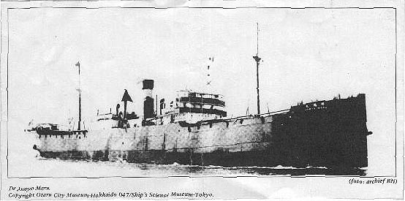  The Junyo Maru - 5620 Dutch, English, Australian and American POWs and Javanese slave labourers died when this Japanese cargo boat was torpedoed, on 18 September 1944 off the south west coast of Sumatra, by a British submarine. | LIST OF CASUALTIES  The list contains the names of 1382 Dutch, 8 US and 3 Australian POWs but not those of about 4000 Javanese slave labourers who also perished.  The names of 56 British POW casualties are listed on the COFEPOW website  N.B. K.N.I.L. (in table below) translates as Royal Netherlands East Indies Army.

Steenwinkel Teunis Adrianus Res. Elt. Gi.K.N.I.L. Oss 23-09-1908
van Steenwijk Cornelis Sold. K.N.I.L. Rotterdam 24-04-1899
van Stein Frans Lorenz Carel Sergt. K.N.I.L. Padang 13-12-1891
Stevens Jean Pierre Ludovicus Sergt. Fourier K.N.I.L. Geleen 23-01-1899
Stevens Michael Johannes Res. Elt. K.N.I.L. Almelo 18-11-1906
Stobberingh Frans George Sold. K.N.I.L. Frutjuk 11-10-1894
Stok Rudolph Eduard - Djokjakarta 20-11-1887
Stolk Arie Sold. Inf. K.N.I.L. Tjipatat 23-05-1886

