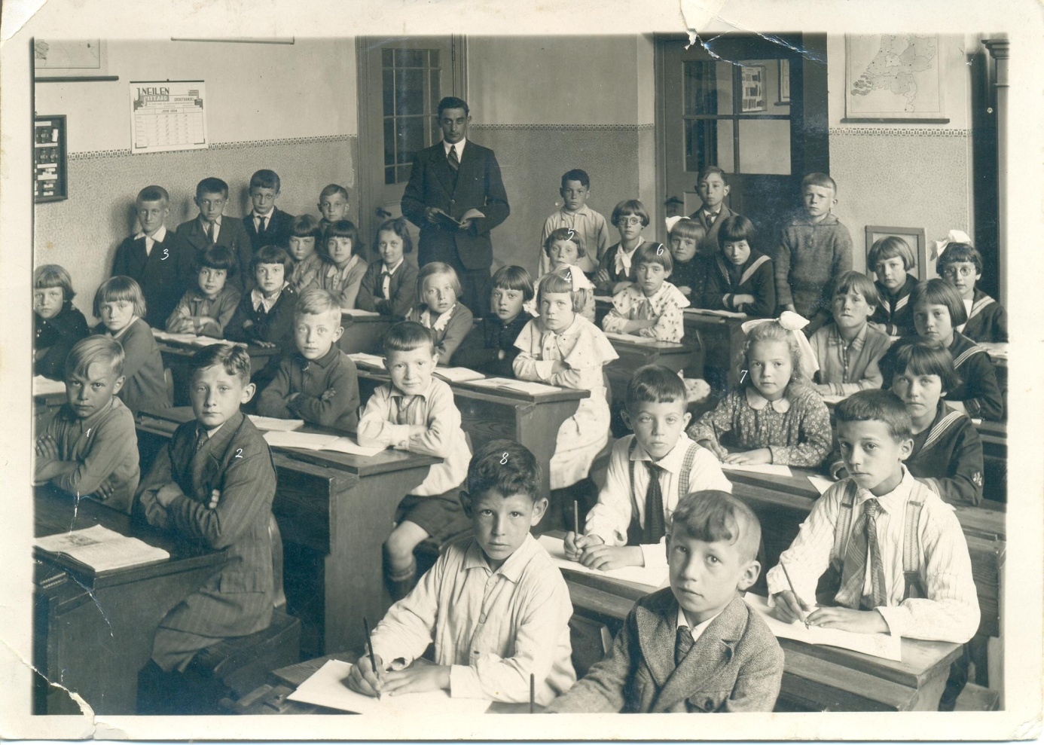
Schoolfoto omstreeks 1931-1935.

- Sjeng Notermans
- Sjra Wagemans
- Harie Schlössels
- Mia (Notermans) Hauwé
- Lies (van Oppen) Dukers
- Tina (Rox) Dukers
- Hubertine Notermans
- Mart? Vleugels

